|  |
| --- |
| **SAFEGUARD GLOBAL** |
| **Invoices** |
| **User Guide** |

**Document ID**

|  |  |  |
| --- | --- | --- |
| Document Type | Status | Name |
| User Guide | Published | Invoices User Guide |

**Revision History**

|  |  |  |  |
| --- | --- | --- | --- |
| Version | Date | Author | Comment |
| 1.0 | 27/01/2025 | Ajit Gupta/Plaban Majumdar |  |
|  |  |  |  |

Table of Contents

Introduction 3

Accessing the Feature 4

Login Instructions 4

Single Invoice Page 5

Page Elements 6

Invoice Balance Color Coding: 6

Invoice Details and Download 6

User Actions 7

Refresh Button 9

Total Overdue Balances 9

Total Outstanding Balances 10

Provide Remittance 11

Glossary Page 12

Invoice Statues Tab 12

Invoice Guide Tab 12

## Introduction

Welcome to the **Invoices User Guide**. This guide provides essential documentation for users of the **Invoices** feature.

**Invoices** is a self-service feature of the Safeguard Global Platform where customers can manage, view, and download invoices from a centralized location.

**Key Benefits:**

* **Instant Access** – No need to wait for responses regarding missing invoices, fee calculations, or overdue balances.
* **Centralized Location** – All invoices are stored in one place, eliminating the need to search emails for past invoices.
* **Real-Time Updates** – View and download invoices as soon as they are generated. Notifications are sent upon invoice creation.
* **Comprehensive Invoice Details** – Access invoice types, sent dates, statuses, values, and balances for easy tracking.
* **Raise a query or provide remittance** directly through the platform for seamless issue resolution and payment tracking.

**Enhanced Features:**

1. **Advanced Search Options**

Quickly find invoices using:

* Invoice number
* Currency
* Sent date or month
* Invoice status
* Invoice type
* Invoice value

1. **Statement of Account (SOA)**

View up-to-date SOA details, including:

* Total overdue amounts
* Total outstanding amounts in respective billing currencies

1. **Customizable Filters**

Filter invoices based on:

* Date range
* Invoice type
* Invoice status
* Project
* Country

1. Users can automatically view total overdue and outstanding balances in their respective billing currencies based on applied filters.

**Additional Resources**

* **Self-Service Invoice Guide** – A detailed explanation of payroll invoice fields and components and their calculations for better understanding.

## Accessing the Feature

You can access the application through the following methods:

1. **Direct URL:** [Invoice Portal](https://invoice-prod.safeguardglobal.com/)
2. **Via the Dashboard:** [Safeguard Global Platform](https://www.app.safeguardglobal.com/)
   * Navigate to **Invoices** via the grid icon.

Upon accessing the portal, the login page will appear (Figure – 1)

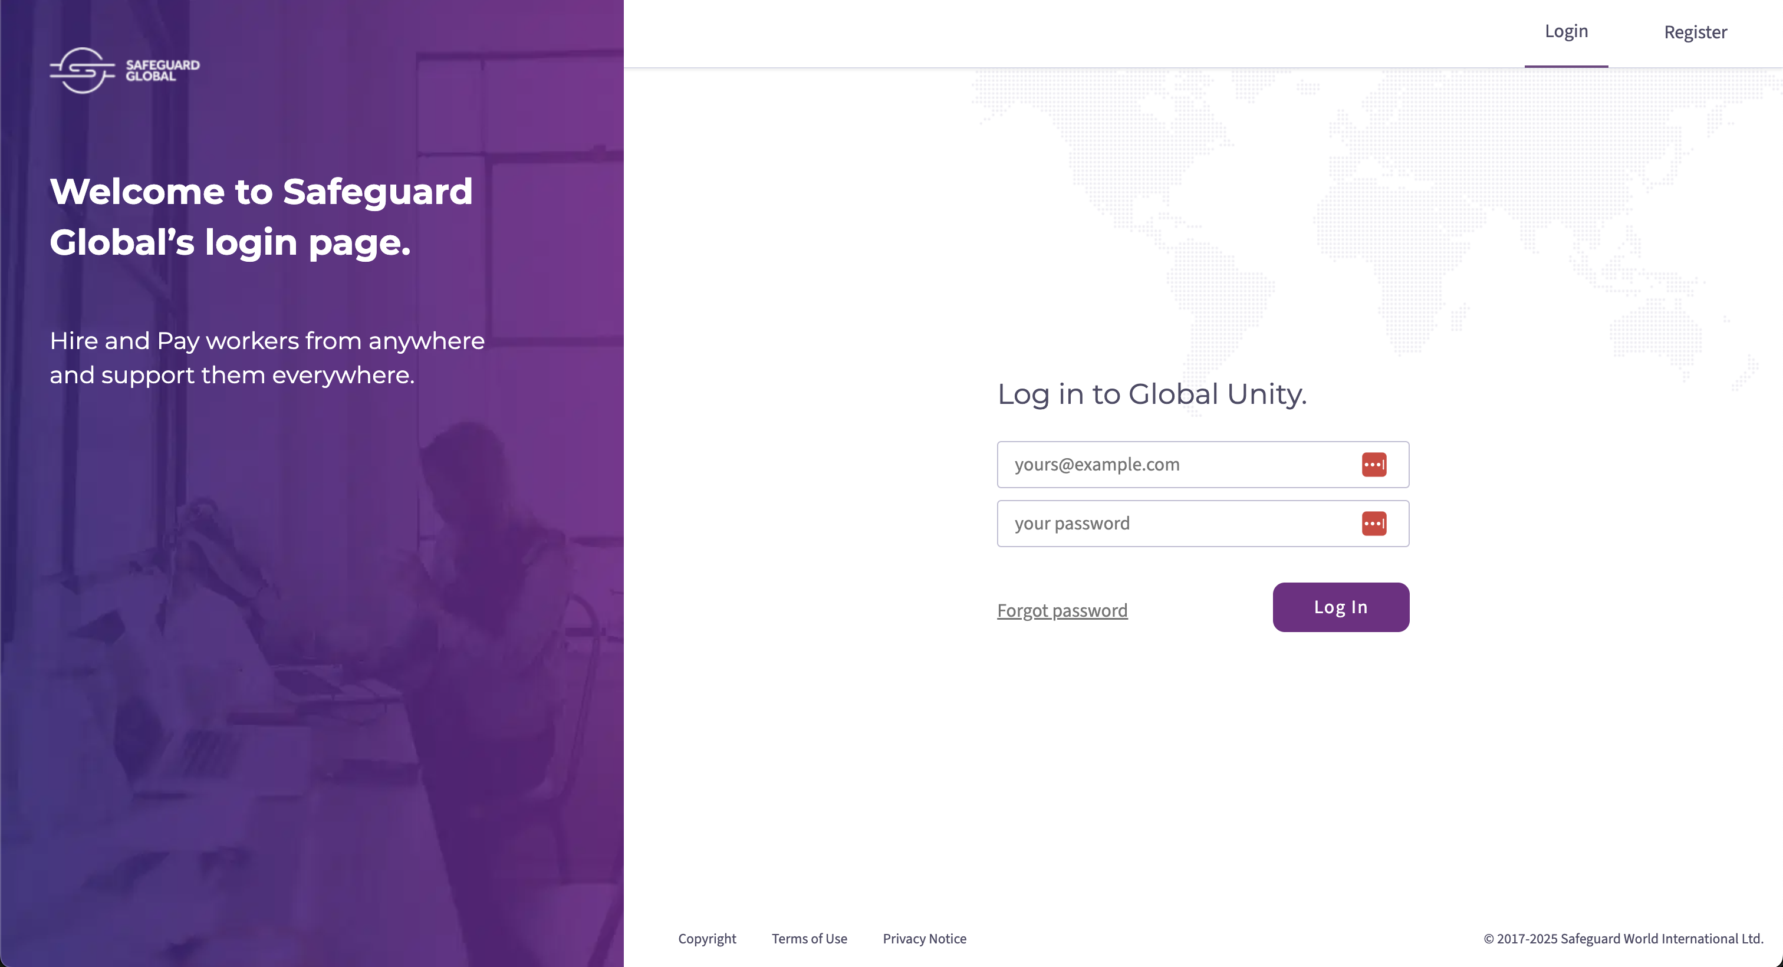

3

Figure 1 – Login page

#### ****Login Instructions****

* If you are a registered user:
  + Enter your email address (point 1 – Figure 1)
  + Enter your password and click **Log In** (point 2 – Figure 1)
* If you do not have an account or need to reset your password:
  + Click **Forgot Password** and follow the instructions (point 3 – Figure 1)

**Navigating the Portal**

* If the user is accessing ‘Invoices’ via the Safeguard Global Platform URL <https://www.app.safeguardglobal.com/>:
  + After logging in, users with **Invoices** feature access can click the **Invoices** tile (Figure - 2) or select **Invoices** from the menu by clicking on the grid icon in the top left corner of the screen (Figure - 3).
  + Users will land on the **Invoices** page, where they can view and manage invoices assigned to their accounts (Figure - 4)
* If the user is accessing the ‘Invoices’ feature through a direct link URL (<https://invoice-prod.safeguardglobal.com/>).
  + Users will land on the **Invoices** page, where they can view and manage invoices assigned to their accounts (Figure - 4)

Figure 2 – Global Unity/ Safeguard platform

3

3

Figure 3 – Global Unity/ Safeguard Platform

## Single Invoices Page

This page allows users to:

* Search, filter, and view invoice details.
* Track overdue and outstanding balances.
* Download invoices.
* Submit remittance request

Note: Invoices are displayed with the latest invoice at the top.

Figure 4 – Single Invoices Page

#### Page Elements

#### Invoices List – Displays details such as invoice number, sent date, type, status, amount, and balance.

#### Search – Find specific invoices.

#### Filters – Apply criteria to narrow down results.

#### Total Overdue Balances – View the sum of overdue invoices.

#### Total Outstanding Balances – See the total outstanding balance.

#### More – Access detailed invoice information and download options.

1. **Provide Remittance –** Submit remittance request

#### Invoice balance color coding:

#### Red – Overdue balance.

#### Green – Paid, closed, or credit balance.

#### Invoice Details and Download

Users can click the **More (>>) button** (point 6 - Figure 4) to access:

* Invoice type, number, and PO number.
* Overdue status and days.
* Invoice status and consolidated ID.
* Invoice value, outstanding balance, sent, and due dates.
* Project, payroll cycle, country, and flag.

Figure 5 – Invoice Details

#### ****User Actions****

* **Raise a Query** **(point 1 – Figure 5)** – Open a support ticket for inquiries for this specific invoice. When the user clicks on this button another slider page will open with a text box and a Submit Query button (Figure 6)
* **Download This Invoice (point 2 – Figure 5)** – Download invoice files as a zip, including an Excel calculation sheet and a PDF invoice.
* **Provide Remittance (point 2 – Figure 5) -** Open a support ticket to provide a remittance request for this specific invoice. When the user clicks on this button another slider page will open. More details are covered in the later section (Figure 12, 13)

Figure 6 – Submit Query

**Search & Filter Functions**

* **Search Function** (point 1 – figure 7)

**Note:** Searching by numbers may bring in all matched results from multiple criteria – invoice number, amount, balance, and date if the following format does not match.

Users can search using**:**

* + Invoice number
  + Invoice type
  + Invoice status
  + Invoice amount/balance
  + Currency
  + Invoice month/year
  + Full invoice date

Figure 7 – Search

* **Filter Function** (point 2 – figure 7): Clicking on the filter button, the slider will open (Figure 8)

Users can filter invoices by:

* **Date Range –** Select a specific date range**.**
* **Invoice Type –** Filter by payroll, setup, deposit, ad-hoc invoices, and credit notes.
* **Invoice Status –** Open, overdue, outstanding, or paid**.**
* **Project & Country –** Filter by customer project or country**.**
* **Reset Filters –** Clear all applied filters**.**
* **Note:** 
  + - Filters adjust dynamically based on invoice data.
    - Selections are gradual and options are presented based on previous selection.

Figure 8 – Filter

Refresh Button

Clicking **Refresh** clears applied searches/filters and retrieves newly generated invoices (Figure 9)

Figure 9 – Refresh

#### Total Overdue Balances

Clicking ‘Total Overdue Balances’ (point 1 – Figure10) displays total overdue amounts in the slider, color-coded for clarity:

* **Red** – Due balance (positive value).
* **Green** – No due balance (negative value)

Figure 10 – Total Overdue Balances

Total Overdue Balances displays balances based on the current selection. By default, it will display the total overdue balance but when the search or filter function is used, the results narrow down the invoices, and the total amount will change based on the current selection.

If there is no overdue balance, no data will be displayed on the slider.

#### Total Outstanding Balances

Clicking Total Outstanding Balances (point 1 – Figure11), displays total outstanding amounts in the Total Outstanding Balance slider based on selected criteria.

* **Red** – Due balance.
* **Green** – No due balance.

Figure 11 – Total Outstanding balances

Total Outstanding Balances displays balances based on the current selection. By default, it will display the total outstanding balance but when the search or filter function is used, the results narrow down the invoices, and the total amount will change based on the current selection.

If no overdue or outstanding balance exists, the section remains empty.

#### Provide Remittance

Users can use the ‘Provide Remittance’ button to submit a remittance request. Once the user presses this button, a slide-out will open the user to fill in details and submit the request. A Zendesk ticket will be created.

Figure 12 – Provide Remittance

By clicking the ‘What is This’ link (point 1-Figure 12), a new slide-out will open that describes remittance.

Figure 13 – What is Remittance

## Glossary Page

The **Glossary** provides key invoice-related definitions.

#### 

#### Invoice Statuses Tab

Explains main invoice statuses and sub-statuses for better understanding (Figure 14)

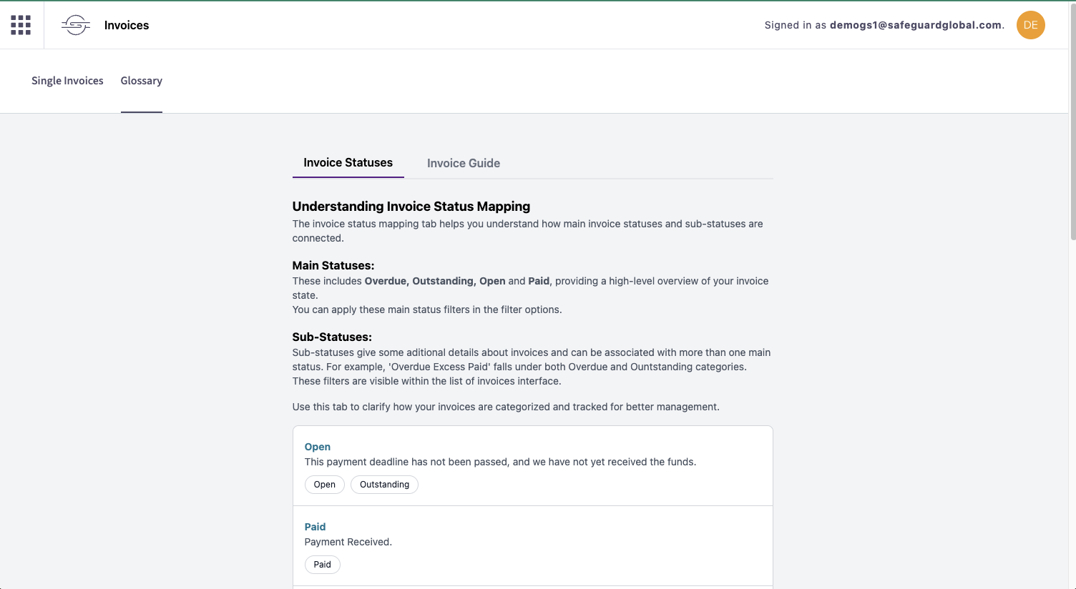

*Figure 14 – Glossary Status*

#### Invoice Guide Tab

Breaks down the Excel calculation sheet sent to customers, explaining elements and SGWI fee calculations (Figure 15)

Figure 15 – Glossary Invoice guide